**Management Accounting**

Management Accounting

Meaning

Management Accounting represents a merger of 2 words management and accounting.

Management- refers to the function of planning direction control etc.

Accounting- refers to record compilation, analysis and presentation of various financial transaction.

In this contact this form of account in is called as Management Accounting.

Definition

According to Robert an Antony management accounting is concern with the accounting information that is useful to management.

Management accounting is a process of identification, measurement, presentation analysis, interpretation and communication of accounting information which assists the management in planning, decision-making direction,control within the framework of fulfilling the organisation objectives.

Nature/characteristics of management Accounting:-

* Both as a science and art
* Accounting service
* Integrated system
* More concern with future
* Selective nature
* More emphasise on the nature of element of cost
* Cause and effect analysis
* Rules not precise and universal
* Supply information and not decision
* Achieving the objective of management

Scope of Management Accounting:-

* Financial accounting
* Cost accounting
* Budgeting and forecasting
* Inventory control
* Reporting to management
* Interpretation of data
* Tax account
* Internal audit

**Module-1**

**Financial Accounting**

Financial accounting is a process of preparing financial statement that companies used to show their financial performance and positions to the investor, creditor supplier and customers etc.

The main objective of financial accounting is to find out the profitability and provide information about the financial position of form or the goods and services.

Two main statements that are prepared under financial accounting.

* Income and expenditure statement
* Balance sheet

**Function of financial statement:-**

* Recording of information
* Classification of data
* Making summaries
* Dealing with financial transactions
* Interpreting financial information
* Communicating results

**Accounting principles:-**

Accounting principles are general rules and guidelines that companies are required to follow when reporting all the accounts and financial data.

Financial principals are further classified into two categories

* Accounting concepts
* Accounting convention

**Accounting concepts:-**

These are necessary assumptions upon which accounting is based.

* Business entity concept
* On going concern concept
* The cost concept
* Dual aspect concept
* Money measurement concept
* Accrual concept
* Match making concept

**Accounting convention:-**

These are the traditional customs that are followed while preparing financial accounting

* Convention of disclosure
* Convention of consistency
* Convention of conservatism
* Convention of materiality

**Accounting cycle:-** 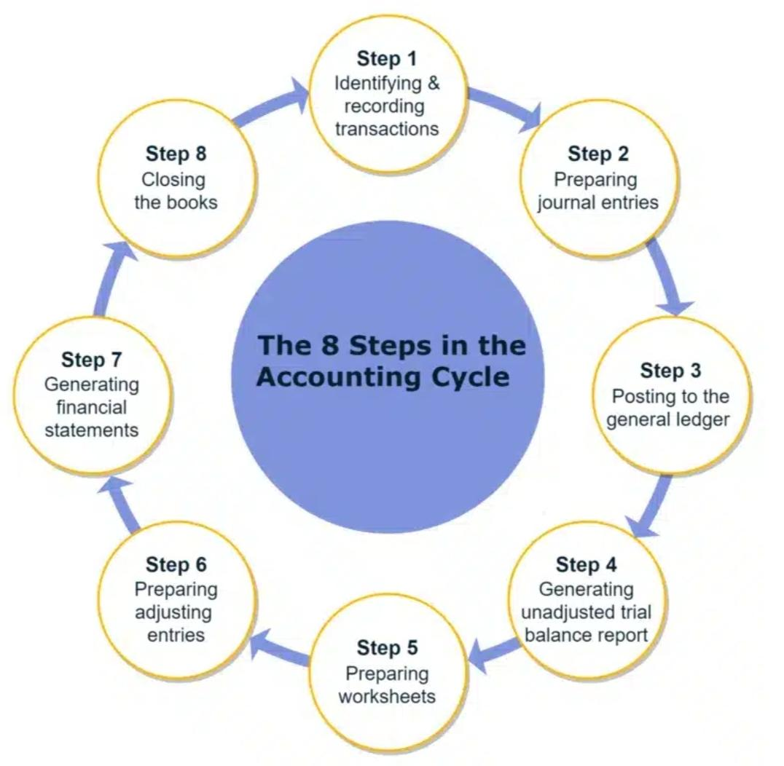

## **The Accounting Cycle: A Step-by-Step Guide**

**The accounting cycle is a systematic process used to record, classify, and summarize financial transactions of a business over a specific period. It ensures accurate financial reporting and provides valuable insights for decision-making.**

### **The 8 Steps of the Accounting Cycle**

1. **Identifying and Recording Transactions:**
   * **Analyze business activities to identify transactions that impact the financial position.**
   * **Examples of transactions include sales, purchases, payments, and receipts.**
2. **Journalizing Transactions:**
   * **Record transactions in chronological order in a journal.**
   * **Each entry includes the date, accounts affected, amounts, and a brief explanation.**
3. **Posting to the General Ledger:**
   * **Transfer journal entries to the general ledger, which is a collection of accounts.**
   * **This process summarizes transactions by account.**
4. **Preparing the Unadjusted Trial Balance:**
   * **List all general ledger accounts and their balances.**
   * **Verify the equality of total debits and credits.**
5. **Preparing the Worksheet (Optional):**
   * **Optional tool to facilitate the adjustment process.**
   * **Contains columns for unadjusted trial balance, adjustments, adjusted trial balance, income statement, and balance sheet.**
6. **Adjusting Entries:**
   * **Record end-of-period adjustments to ensure accurate financial statements.**
   * **Examples include accruals, deferrals, depreciation, and bad debts.**
7. **Preparing Financial Statements:**
   * **Create the income statement, balance sheet, and statement of cash flows.**
   * **These statements provide a summary of the company's financial performance and position.**
8. **Closing Entries:**
   * **Transfer temporary accounts (revenues, expenses, and dividends) to retained earnings.**
   * **Prepare the company's books for the next accounting period.**

### 

### **Importance of the Accounting Cycle**

* **Accurate financial reporting: Ensures reliable financial information for decision-making.**
* **Compliance with accounting standards: Adheres to generally accepted accounting principles (GAAP).**
* **Effective decision-making: Provides valuable insights into the company's financial health.**
* **Tax compliance: Supports accurate tax filings.**

**By following the accounting cycle diligently, businesses can maintain accurate financial records and make informed decisions.**